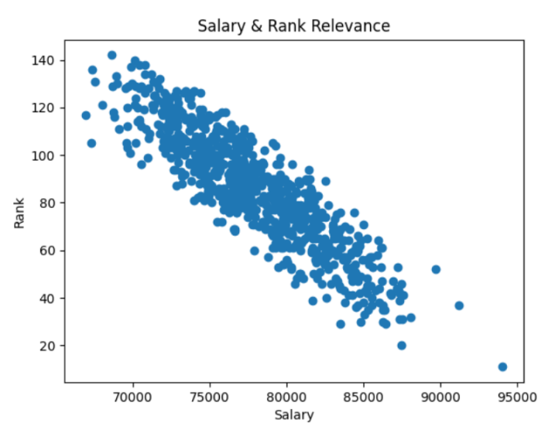

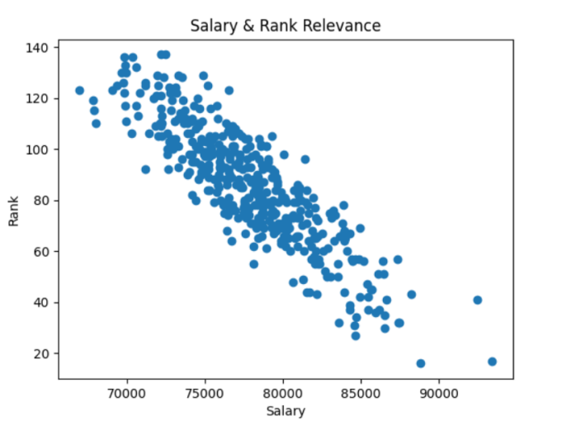

Both public and private schools can see a correlation between school ranking and salary levels, so the public attribute is not called a key factor in the rebuttal

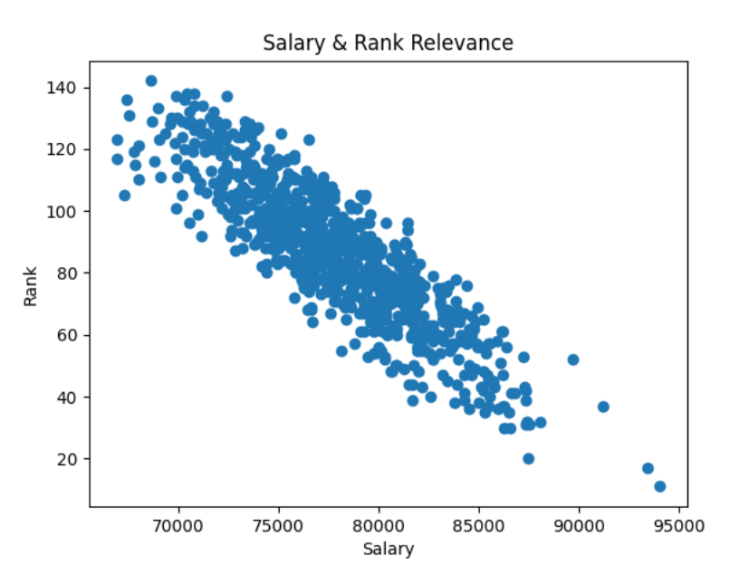

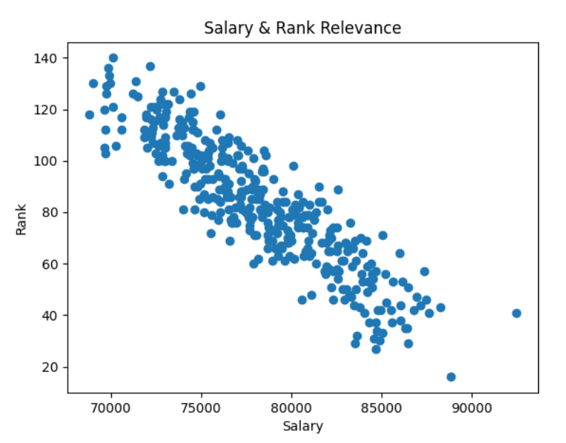

The plotting result of the Instate attribute is the same as the Public attribute, and is not the main factor affecting the relationship between Rank and Salary

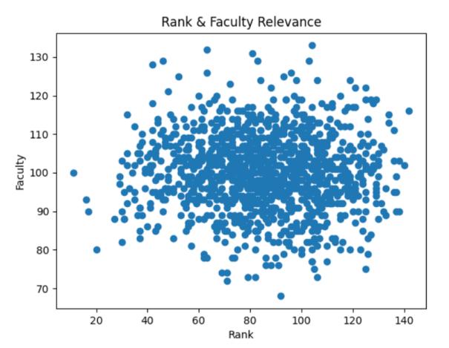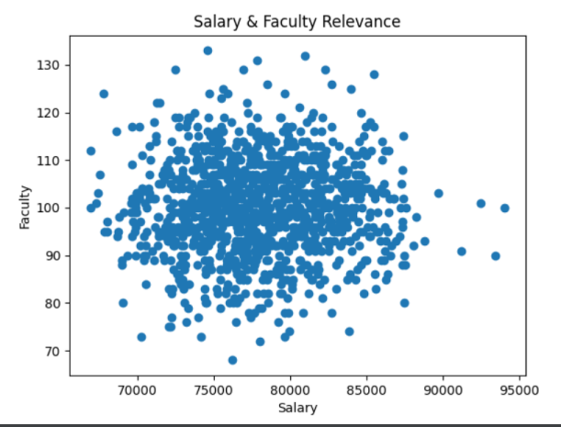

There is no significant correlation between school staff size and Rank and student post-graduation Salary

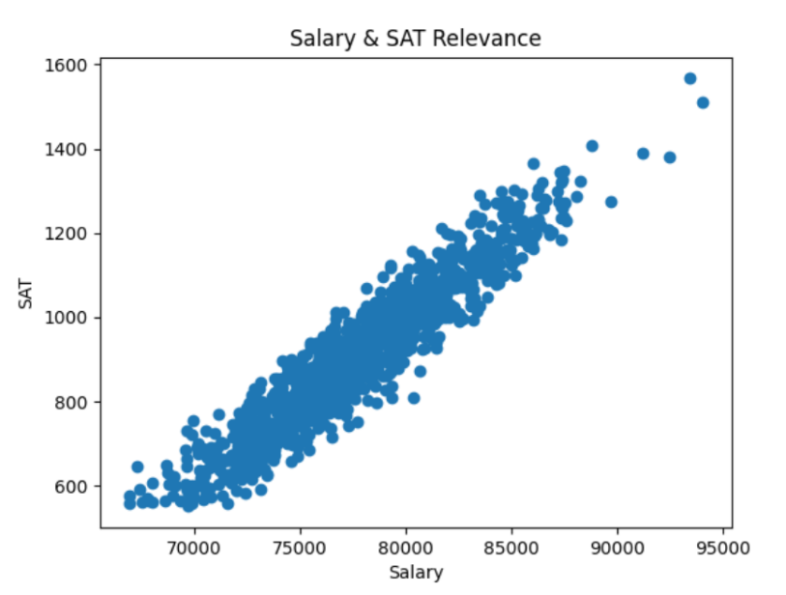

The graph shows that there is a significant linear correlation between Salary and SAT scores. The higher the SAT score, the higher the Salary.

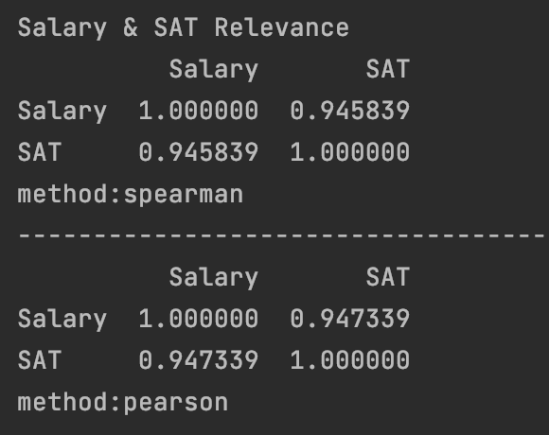

The conclusion that Salary and SAT scores are related was verified by the Pearson and Spearman formula.

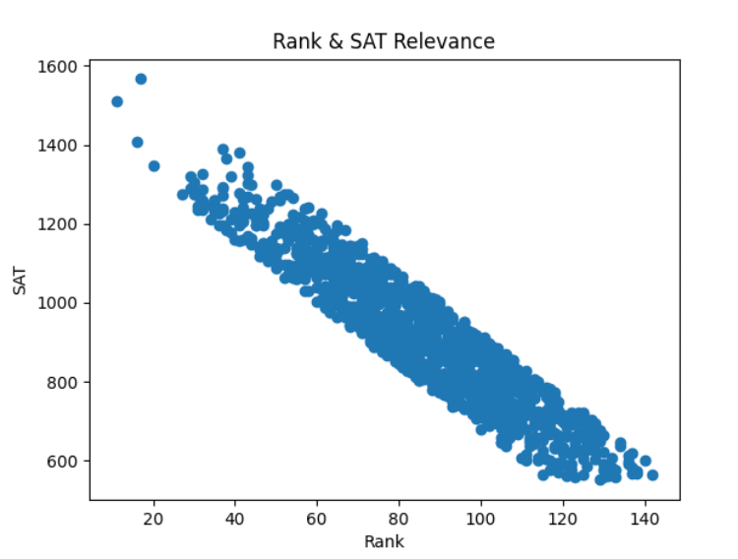

A linear relationship between the two factors was found by plotting the relationship between SAT and Rank. The higher the school ranking, the higher the student's SAT score. According to my speculation, students generally have better SAT scores at school, which proves that students are more capable of learning. Students who are more capable are naturally more likely to earn higher salaries in the workplace.

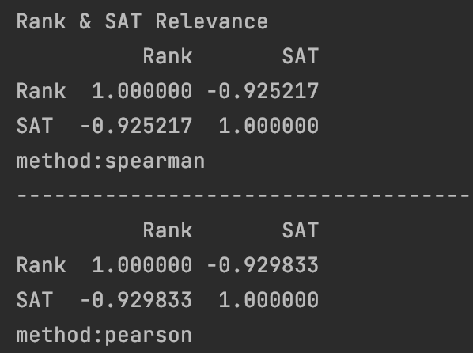

Calculations show a negative correlation between SAT scores and school ranking.

Therefore, it is not necessarily the school's Rank that determines a student's salary after graduation. We can continue to maintain the relatively small importance of college rankings conclusion. Although there is a correlation between Rank and Salary, universities do not give other data to prove that students who graduate from schools with greater Rank have higher Salary after graduation. Therefore the conclusion of the non-profit organization can continue to be used.